
Dynamic IPv6 Routing using RIPng Protocol in Cisco Packet Tracer
Project Report

Name: Symbol Rani & Rimsha katpar
Course: Computer Netwroks & Data Communication
Submitted to: Sir Muhammad Bux
Date: May 29, 2026

Table of Contents
# | Topic | Page
1 | Introduction | 2
2 | Objectives | 2
3 | Technologies Used | 3
4 | Purpose of Technologies Used | 3
5 | Network Topology | 5
6 | IPv6 Addressing Table | 6
7 | Hardware & Module Configuration | 7
8 | Router Configuration | 8
9 | RIPng Configuration | 10
10 | PC Configuration | 11
11 | Testing and Verification | 12
12 | Troubleshooting | 13
13 | Conclusion | 14
14 | References | 14

1. Introduction
This project presents the design and implementation of an IPv6-based routed network using Cisco Packet Tracer. The network simulates a multi-router environment where multiple end devices communicate across different IPv6 subnets using dynamic routing.
The project includes important networking technologies such as IPv6 addressing, RIPng (Routing Information Protocol next generation) , static IPv6 configuration, and serial WAN connections. Three routers were interconnected using serial DCE links to simulate a wide area network (WAN) environment.
RIPng was configured as the dynamic routing protocol to automatically share IPv6 route information between routers, eliminating the need for manual static routes. End devices (PCs) were configured with IPv6 addresses and default gateways to enable cross-network communication.
The project demonstrates how IPv6 and RIPng can be implemented to create a scalable, efficient, and modern network infrastructure suitable for enterprise environments transitioning from IPv4 to IPv6.

2. Objectives
The objectives of this project are:
1 | To design and simulate an IPv6-based routed network using Cisco Packet Tracer
2 | To configure IPv6 addresses on routers and end devices
3 | To implement serial WAN connections between routers using Serial DCE cables
4 | To configure RIPng for dynamic IPv6 routing
5 | To enable inter-network communication across different IPv6 subnets
6 | To verify routing tables and route propagation using show ipv6 route
7 | To test connectivity using ICMPv6 ping between devices in different networks
8 | To understand the differences between IPv4 and IPv6 routing protocols

3. Technologies Used
Technology | Purpose
IPv6 Addressing | Next-generation IP addressing for end devices and routers
RIPng | Dynamic routing protocol for IPv6 networks
Serial DCE | WAN connection between routers with clock rate configuration
GigabitEthernet | LAN connections between routers and end devices
ICMPv6 | IPv6 ping testing and verification
Cisco Packet Tracer | Network simulation and testing environment
SLAAC / Static IPv6 | IPv6 address assignment for end devices

4. Purpose of Technologies Used

IPv6 (Internet Protocol version 6)
IPv6 was used as the primary addressing scheme for all routers and end devices in the network. IPv6 provides a significantly larger address space compared to IPv4 and eliminates the need for NAT (Network Address Translation).
Benefits:
- Larger address space (128-bit addresses)
- Built-in IPsec support
- Simplified header format
- Autoconfiguration capabilities (SLAAC)
- No need for NAT

RIPng (Routing Information Protocol next generation)
RIPng is the IPv6 version of RIP (Routing Information Protocol). It was used as the dynamic routing protocol to automatically exchange IPv6 route information between routers.
Benefits:
- Automatically learns routes to remote networks
- Eliminates manual static route configuration
- Uses UDP port 521 for communication
- Simple configuration and easy to troubleshoot
- Suitable for small to medium IPv6 networks

Serial DCE (Data Communications Equipment)
Serial DCE cables were used to connect routers together, simulating WAN links between different geographical locations. The DCE end requires a clock rate to be set for synchronization.
Benefits:
- Simulates real-world WAN connections
- Requires clock rate configuration (practical skill)
- Supports point-to-point connectivity
- Cost-effective in simulation environments

GigabitEthernet
GigabitEthernet interfaces were used to connect routers to end devices (PCs), providing high-speed LAN connectivity.
Benefits:
- High bandwidth (1 Gbps)
- Standard for enterprise LAN connections
- Reliable and widely supported

ICMPv6 (Internet Control Message Protocol version 6)
ICMPv6 was used for testing connectivity between devices using the ping command. It also plays a critical role in neighbor discovery and autoconfiguration.
Benefits:
- Essential for network troubleshooting
- Verifies end-to-end connectivity
- Confirms routing protocol functionality

Cisco Packet Tracer
Cisco Packet Tracer was used as the network simulation tool for designing, configuring, and testing the RIPng IPv6 network.
Benefits:
- Safe testing environment without physical hardware
- Realistic Cisco IOS command-line interface
- Easy visualization of network topology
- Excellent learning tool for certification preparation

5. Network Topology
The network topology consists of:
Component | Quantity
Routers (ISR 4321 / 2911) | 3
PCs | 3
Serial DCE Links | 2
GigabitEthernet Links | 3

Network Topology
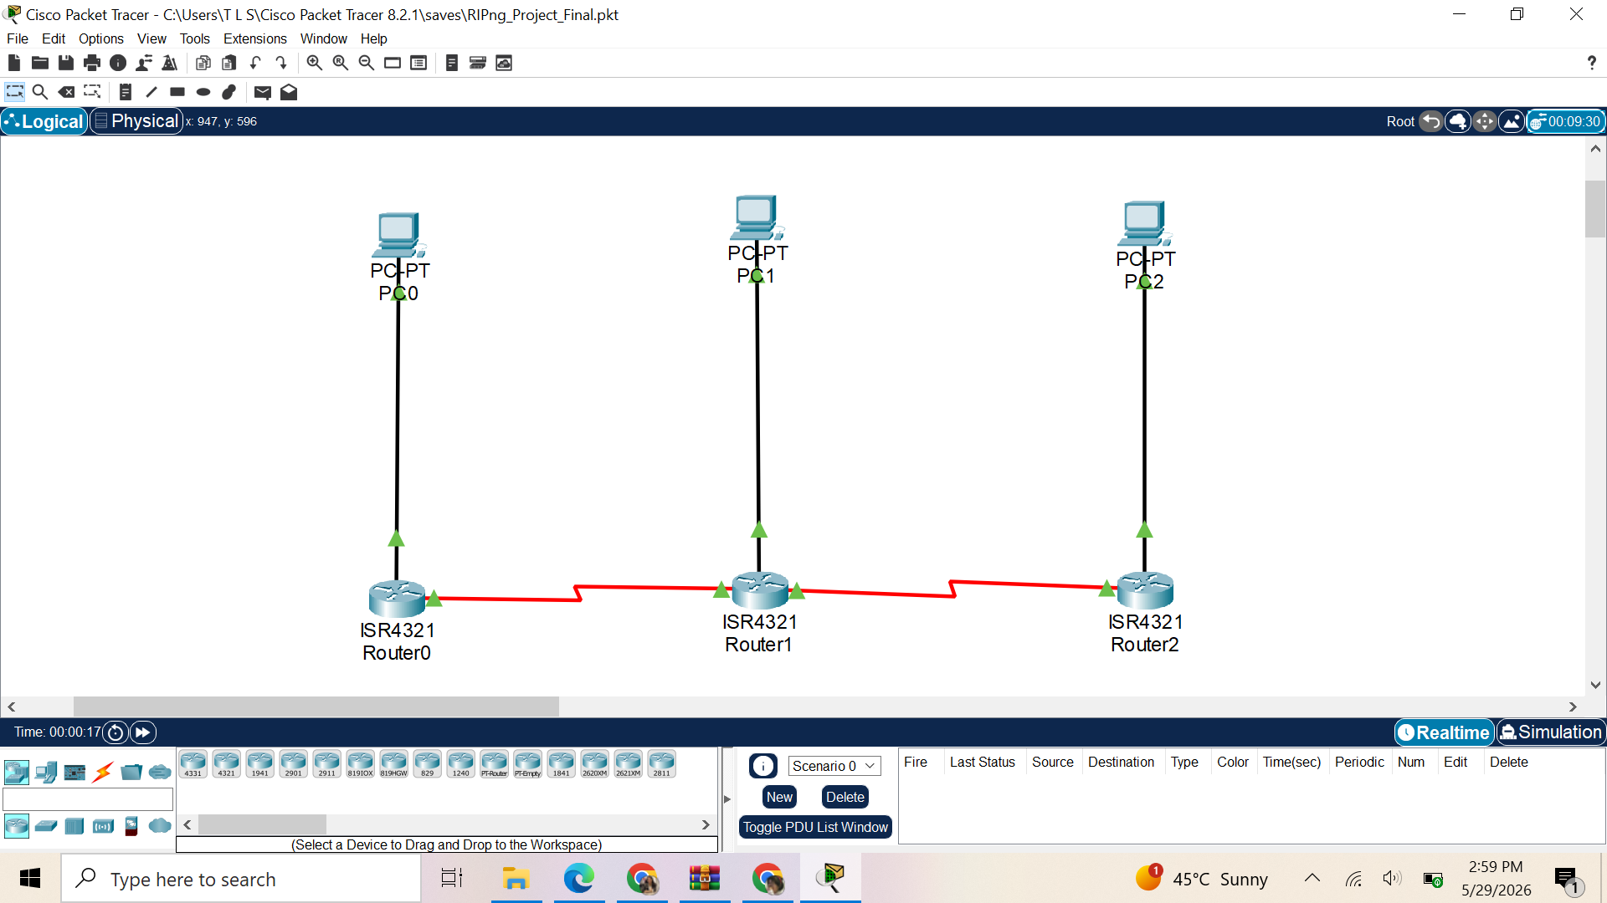

IPv6 Subnets Used
Subnet | Purpose | Network Address
Subnet A | PC0 Network | 2001:db8:1::/64
Subnet B | PC1 Network | 2001:db8:2::/64
Subnet C | PC2 Network | 2001:db8:3::/64
Subnet D | R0 ↔ R1 Link | 2001:db8:12::/64
Subnet E | R1 ↔ R2 Link | 2001:db8:23::/64

6. IPv6 Addressing Table

Router Interfaces
Router | Interface | IPv6 Address | Connected To
Router0 | GigabitEthernet0/0/0 | 2001:db8:1::1/64 | PC0
Router0 | Serial0/1/0 | 2001:db8:12::1/64 | Router1
Router1 | GigabitEthernet0/0/0 | 2001:db8:2::1/64 | PC1
Router1 | Serial0/1/0 | 2001:db8:12::2/64 | Router0
Router1 | Serial0/1/1 | 2001:db8:23::1/64 | Router2
Router2 | GigabitEthernet0/0/0 | 2001:db8:3::1/64 | PC2
Router2 | Serial0/1/0 | 2001:db8:23::2/64 | Router1

End Devices (PCs)
Device | Interface | IPv6 Address | Link Local Address | Default Gateway (Link Local)
PC0 | FastEthernet0 | 2001:DB8:1:0:2E0:B0FF:FE86:5EA7 | FE80::2E0:B0FF:FE86:5EA7 | FE80::204:9AFF:FEA2:EE01
PC1 | FastEthernet0 | 2001:DB8:2:0:20A:41FF:FEE2:D773 | FE80::20A:41FF:FEE2:D773 | FE80::204:9AFF:FEA2:EE01
PC2 | FastEthernet0 | 2001:DB8:3:0:2E0:A3FF:FE06:6410 | FE80::2E0:A3FF:FE06:6410 | FE80::204:9AFF:FEA2:EE01

7. Hardware & Module Configuration

NIM-2T Module Installation
The ISR 4321 routers do not have built-in serial ports. The NIM-2T (2-port Serial Network Interface Module) was added to each router to enable serial WAN connectivity.
Steps to add NIM-2T:
- Click on Router → Physical tab
- Power OFF the router using the power switch
- Drag NIM-2T module from the modules list into an available slot
- Power ON the router
- Verify serial ports appear using show ip interface brief

8. Router Configuration

Router0 Configuration
cisco
enable
configure terminal
hostname R0

! Enable IPv6 routing
ipv6 unicast-routing

! Configure GigabitEthernet interface to PC0
interface gigabitethernet0/0/0
ipv6 address 2001:db8:1::1/64
ipv6 rip RIPNG enable
no shutdown
exit

! Configure Serial interface to Router1
interface serial0/1/0
ipv6 address 2001:db8:12::1/64
ipv6 rip RIPNG enable
clock rate 64000
no shutdown
exit

! Enable RIPng
ipv6 router rip RIPNG
exit

! Save configuration
write memory

Router1 Configuration
cisco
enable
configure terminal
hostname R1

! Enable IPv6 routing
ipv6 unicast-routing

! Configure GigabitEthernet interface to PC1
interface gigabitethernet0/0/0
ipv6 address 2001:db8:2::1/64
ipv6 rip RIPNG enable
no shutdown
exit

! Configure Serial interface to Router0
interface serial0/1/0
ipv6 address 2001:db8:12::2/64
ipv6 rip RIPNG enable
no shutdown
exit

! Configure Serial interface to Router2
interface serial0/1/1
ipv6 address 2001:db8:23::1/64
ipv6 rip RIPNG enable
clock rate 64000
no shutdown
exit

! Enable RIPng
ipv6 router rip RIPNG
exit

! Save configuration
write memory

Router2 Configuration
cisco
enable
configure terminal
hostname R2

! Enable IPv6 routing
ipv6 unicast-routing

! Configure GigabitEthernet interface to PC2
interface gigabitethernet0/0/0
ipv6 address 2001:db8:3::1/64
ipv6 rip RIPNG enable
no shutdown
exit

! Configure Serial interface to Router1
interface serial0/1/0
ipv6 address 2001:db8:23::2/64
ipv6 rip RIPNG enable
no shutdown
exit

! Enable RIPng
ipv6 router rip RIPNG
exit

! Save configuration
write memory

9. RIPng Configuration
RIPng was enabled on all routers using the following commands:

RIPng Configuration Summary
Router | Command | Purpose
All Routers | ipv6 unicast-routing | Enable IPv6 routing globally
All Routers | ipv6 router rip RIPNG | Create RIPng process
Per Interface | ipv6 rip RIPNG enable | Enable RIPng on interface

10. PC Configuration

PC0 Configuration
Setting | Value
IPv6 Address | 2001:DB8:1:0:2E0:B0FF:FE86:5EA7
Link Local Address | FE80::2E0:B0FF:FE86:5EA7
Default Gateway | FE80::204:9AFF:FEA2:EE01
Configuration Method | Autoconfigure

PC1 Configuration
Setting | Value
IPv6 Address | 2001:DB8:2:0:20A:41FF:FEE2:D773
Link Local Address | FE80::20A:41FF:FEE2:D773
Default Gateway | FE80::204:9AFF:FEA2:EE01
Configuration Method | Autoconfigure

PC2 Configuration
Setting | Value
IPv6 Address | 2001:DB8:3:0:2E0:A3FF:FE06:6410
Link Local Address | FE80::2E0:A3FF:FE06:6410
Default Gateway | FE80::204:9AFF:FEA2:EE01
Configuration Method | Autoconfigure

11. Testing and Verification
The following tests were performed successfully:

Test 1: Verify Router Interfaces
Command: show ip interface brief
Router | Interface | Status | Protocol
R0 | Gig0/0/0 | up | up
R0 | Serial0/1/0 | up | up
R1 | Serial0/1/0 | up | up
R1 | Serial0/1/1 | up | up
R2 | Gig0/0/0 | up | up
R2 | Serial0/1/0 | up | up

Test 2: Verify IPv6 Routing Table (R0)
Command: show ipv6 route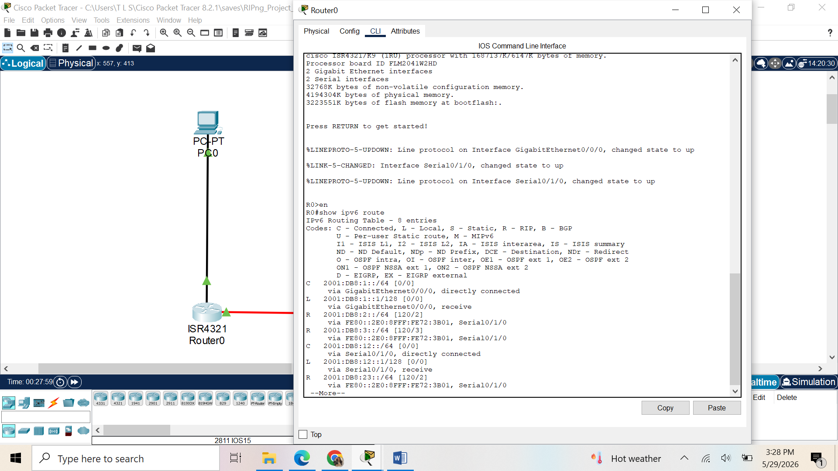

Test 3: Ping Test from PC0 to PC1
Command: ping 2001:DB8:2:0:20A:41FF:FEE2:D773
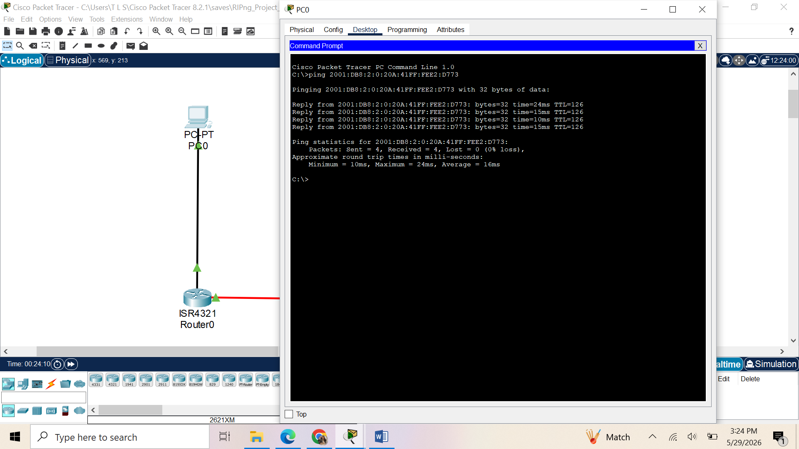

Test 4: Ping Test from PC2 to PC1
Command: ping 2001:DB8:3:0:2E0:A3FF:FE06:6410
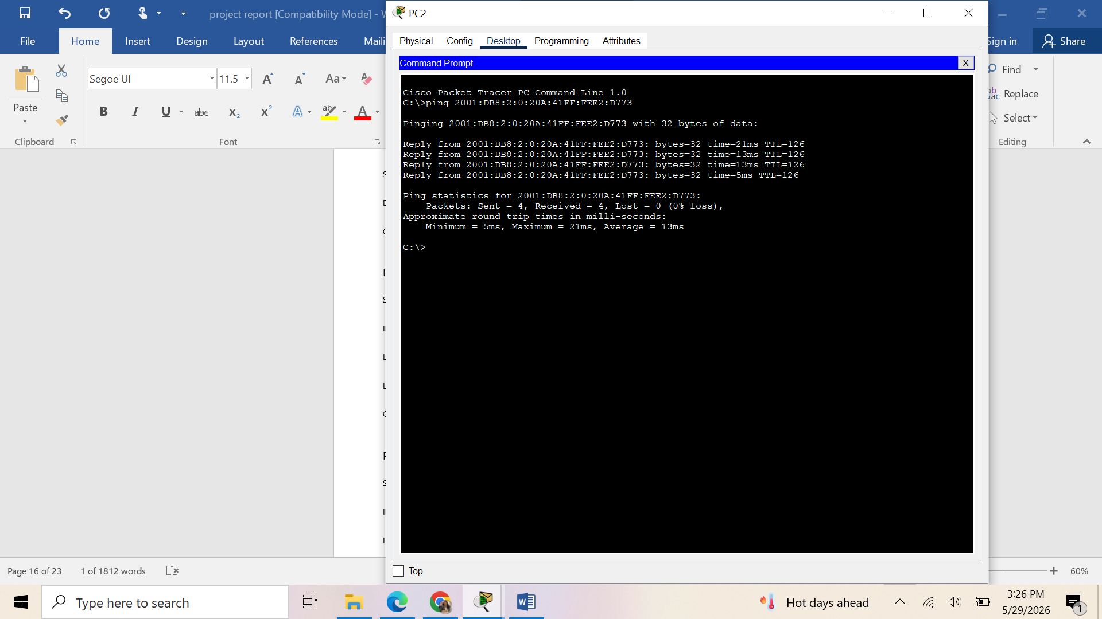

12. Troubleshooting
Some issues encountered during implementation and their solutions:
# | Issue | Solution
1 | Serial ports not visible on ISR 4321 | Added NIM-2T module in Physical tab
2 | Serial interface showing "down/down" | Used no shutdown command on both ends
3 | Clock rate not set | Configured clock rate 64000 on DCE end
4 | No IPv6 routes in routing table | Verified ipv6 unicast-routing was enabled
5 | RIPng not sharing routes | Ensured ipv6 rip RIPNG enable on all interfaces
6 | PC IPv6 address not saving | Used Autoconfigure method in IP Configuration
7 | Ping showing "Destination host unreachable" | Verified default gateway (FE80::204:9AFF:FEA2:EE01) on PCs
8 | Serial ports on different numbers (0/1/0 vs 0/0/0) | Checked physical module slot placement
Key Learning: Always verify interface status using show ip interface brief before testing connectivity. IPv6 link-local addresses are used as default gateways in IPv6 networks.

13. Conclusion
This project successfully demonstrated the implementation of an IPv6-based routed network using RIPng as the dynamic routing protocol in Cisco Packet Tracer.
The network allowed communication between devices in different IPv6 subnets:
- PC0 (2001:DB8:1:0:2E0:B0FF:FE86:5EA7) successfully communicated with PC1 (2001:DB8:2:0:20A:41FF:FEE2:D773)
- PC0 successfully communicated with PC2 (2001:DB8:3:0:2E0:A3FF:FE06:6410)
RIPng was successfully configured to automatically share route information between all three routers, eliminating the need for manual static route configuration. Serial DCE links were properly configured with clock rates to simulate real-world WAN connections.
The project provided practical understanding of:
- IPv6 addressing and subnetting
- RIPng dynamic routing protocol configuration
- Serial WAN link implementation
- Network troubleshooting using show and ping commands
- Cisco IOS command-line interface
- IPv6 link-local addresses as default gateways
This project serves as a foundation for understanding modern IPv6-based enterprise networks and the transition from IPv4 to IPv6.

14. References
# | Reference
1 | Cisco Networking Academy. (2024). IPv6 Fundamentals and RIPng Configuration
2 | Cisco Packet Tracer Documentation
3 | RFC 2080 - RIPng for IPv6
4 | RFC 8200 - Internet Protocol, Version 6 (IPv6) Specification
5 | Cisco Systems. (2023). Configuring RIPng on Cisco Routers
6 | Computer Networking Laboratory Manual - IPv6 Routing

